Michael Serrano

Professor Emily Vera

ACCT 2200 EO2

09, February 2021

Financial Analysis Project Part 1

1. Describe the history, development, and primary operations of the corporation. What do you find interesting about the company? Why did you choose this company? Obtain this information from the 10-K, company website, Google, etc. (Limit discussion on #1 to the one-page maximum.) (4 points)

Apple was created in 1976, by Steve Wozniak and Steve Jobs who wanted to create portable and user-friendly computers that weren't available to the consumer. So, Jobs and Wozniak started to build their first computer in Job’s garage called the Apple 1 which they sold and funded their new company Apple.

After this, Apple would build Apple 2 in 1977, microcomputer Lisa in 1979, and finally introduced Macintosh in 1983. 2 years later in 1985, Jobs would later leave the company and not come back until 1996 where he would spearhead great inventions such as the iPod, the iMac series of computers, and the first-ever touchscreen smartphone called the iPhone. Since then, the company’s new CEO Tim Cook has created the Airpods and Apple Watch.

Apple has three main components that work together to think, create and sell the product to the customer. The corporation has its major headquarters in California where the company has created major products such as the iPhone and the iMac. The headquarters usually act as a way to test prototypes but also check the quality of products, where the products should go, and how much is available. After the prototype is finished in the headquarters it then moves on to the assembling stage which is located in China. Every day the materials are stored, then moved to assemble which if done correctly will be tested and inspected to make sure the product meets the company standards. Afterwards, the products are shipped back to Apple to sell in retail or shipped straight to the person who buys the product. Apple retail is greatly different than the first two ways Apple works, and it’s usually the only side a consumer sees. Their primary goals are to sell the products to customers and ensure good interaction with each customer. However, certain tasks such as fixing products, demo shows, and checking the inventory of the story are also done here. Apple is a complex corporation that is broken down into many different parts that work together.

Apple has a very strict structure that makes creating and selling an easy process, I found this process very interesting as I never really understood what made Apple so good at selling their products. I also chose this company as their products were always perfect and usable, I wanted to know why.

2. What is the purpose of the section of the 10-K entitled "Management Discussion and Analysis"? Discuss this portion of the 10-K. What is interesting? What can you tell about the company and their management? (3 points)

The purpose of the section of the 10-k entitled “Management Discussion and Analysis” is to compare two years’ worth of net sales from item to item with this year’s numbers. So, they do this by calculating the difference in percentages of the two net sales of each year, they then use these numbers to find out where to increase advertising or when to decrease the inventory of the next year. The company seems very stable in its net sales of the last couple of years which means that their management is trained well and has no weak internal controls. I wanted to add that I also found the fact that Apple in China is decreasing every year from the past two years based on low net sales of iPhones.

3. What has been the lowest price of the common stock in the last year? What has been the highest price of the common stock in the last year? Include a one year historical graph of stock price – you can get this graph from yahoo finance.(3 points)

The lowest price of the common stock this year has been 57 dollars and 31 cents or 57.31 on March 26th. Surprisingly there was an article by Apple Insider about this day, which talked about the preorder option for the new iPads. Unfortunately, it was only a rumor and the stocks took a hit which could explain the price. The highest price of the stock this year has been 139 dollars and 7 cents or 139.07 on January 18th, this stock price could be linked to the new Homepod available in China that Apple recently announced.

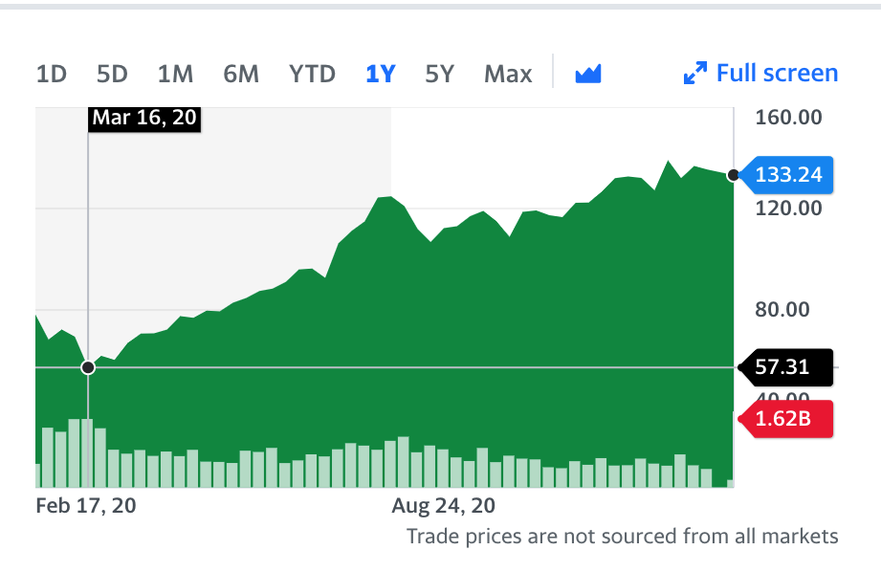

4. What has been the trend in the stock price over the past year from today’s date and prior (upward, downward, volatile)? Find at least one piece of news that is reflected in stock price and discuss the event and change in stock price. This could be the announcement of a new product, mergers, acquisitions, etc. Discussion required here. This discussion must be in your own words and your interpretation of the stock price. (4 points)

The trend in the stock price over the past year from today’s day and prior has been upward. I think it’s this way because Apple focused on small gadgets and services this year instead of fixating on larger new products or redesigning of old ones, I think the biggest tell was during the Worldwide Developer Conference which Apple usually takes part in. There is an article by TechCrunch which went over all of the new updates and products Apple would come out with within 2020. The most important news articles during this time referenced the iOS 14 update, the new AirPods, and the new Apple Watch. Which is very interesting as the biggest gain for this year’s net sales are in services and portable appliances which are items that Apple had rolled out for 2020. These gadgets and services could help Apple stay stable and even increase the stock price after each rollout of a product or service that was featured in the Worldwide Conference. Also, they couldn’t come out with big products since most people would be at home because of the Covid-19 pandemic.

5. Has there been a growth in profits (Net Income) over prior years? Discuss and include the net income numbers for the last two years. If you do see growth, why? If not, why not? Obtain the earnings per share amounts from the face of the income statement and include these in your discussion. A discussion is required here about the company income fluctuations, EPS, and what has been going on with the company to contribute to income fluctuations. Again, this discussion must be in your own words and your interpretation of company profits, EPS, etc. (4 points)

There has been a small positive increase of 2,155 in net income from the last year which was 55,256 to this year which was 57,411. However, in the last two years, the net income went from a high number such as 59,531 in 2018 to a lower number such as 55,256 in 2019 that made the change between the two years a negative 4,275. I think the numbers decreased and increased between the two years because they weren’t selling as much in 2019 due to the lack of new products that came out. Most of the things Apple rolled out were software updates to the new iPhones, iMacs, and Apple Watches and these updates turned out to be the biggest thing apple did that year besides the Airpod Pros which many Apple Users already had the original for a smaller price. So, I can see how Apple might take a hit in net income between the two years.

The earnings per share did increase from 2019 to 2020, the basic went up .32 from 2.99 in 2019 to 3.31 in 2020 while the diluted went up .31 from 2.97 in 2019 to 3.28 in 2020. All this means is that the common stock and convertible securities had gone up which could be from the higher net sales in 2020. However, just like in the net income, the change between the years 2018 and 2019 are negative. I do think that Apple does fluctuate from year to year based on what they put out but also what they focus on during that year.

6. What does the 10-K and/or company website say regarding ethic responsibility as a company? Do you think this is sufficient? Is the company doing their part to create an ethical workplace? In your opinion, are they maintaining ethical practices? If you cannot find this information in the 10-K, Google the company name and ethics. Research the company’s ethical policies and summarize. (3 points)

I thought going into the ethics about Apple, that there were going to be some skeletons in the closet that people would not know about. However, after reading up about cases that affected Apple, I can see that they do have a better ethical company than most. Apple pays money into the Daniel’s Ethics Fund and has created new policies to fit the changing world. Obviously, Apple is not a perfect ethical company as they do outsource their manufacturing to China and other poorer regions in the world. Most of the time these places don’t provide a good working environment or a good schedule for the people and sometimes children working there. I think about the article written by the Guardian which discussed a case of children dying and getting injured for digging out cobalt that would be shipped to major technology companies such as Apple. Now later on that same year Apple would respond by saying they “removed six cobalt refiners in 2019.” as a result of this, which was good on Apple’s part but left the question as to whether they had other unethical connections in their business. So, they are better than most companies, but they do have a couple of problems that do seem very unethical.

7. Invest or Not? Given your research thus far, would you invest in this company? Why or why not? Justify your decision based on the 6 questions preceding this. Discussion here is approximately 1 page. (5 points)

I think you should invest in Apple as the net sales are higher than they were in 2019 which means Apple is doing very well in the stock market and the risk of losing money is smaller. There is still a risk of losing money since the pandemic is still happening and the company’s change from 2018 to 2019 is negative but that could be due to the products and services Apple rolls out during that year. I would start looking at the product history to find out more about which product would come out, the best source for which products come out is the Worldwide Developer Conference which takes place June 22nd of every year. This conference can tell you whether Apple is going software updates, new products or redesigning of old products. Based on their 10k, Apple went with handheld devices and services during the year 2020 as a result of the Covid-19 pandemic. Apple knew that people wouldn’t be going outside the house much and their products would be smaller, so they decided to improve this branch of their products. So, the company really does look into events that could happen and make a smart plan on how to have stable inflow of money.

If you do want to invest a company that is more ethical than other companies, Apple would be a great option. They do have certain problems with human rights and outsourcing their manufacturing, but they do try to change their ways in the form of new policies that have tackled issues such as climate change and racism. Apple does change their polices very frequently so it’s important to see the news and then make the decision on whether to support the company and invest. At the end of the day, remember that Apple is less of a risk than other major companies so it would greatly benefit you to considered investing in Apple.

Sources:

“Steve Jobs and Steve Wozniak.” *Lemelson*, [lemelson.mit.edu/resources/steve-jobs-and-steve-wozniak.](https://lemelson.mit.edu/resources/steve-jobs-and-steve-wozniak)

Staff, AppleInsider. “Apple Rumored to Begin Retail IPad Sales March 26.” AppleInsider, AppleInsider, 3 Mar. 2010, [appleinsider.com/articles/10/03/03/apple_rumored_to_begin_retail_ipad_sales_march_26.](https://appleinsider.com/articles/10/03/03/apple_rumored_to_begin_retail_ipad_sales_march_26)

“HomePod Available in China Starting Friday, January 18.” Apple Newsroom, 19 Feb. 2021, [www.apple.com/newsroom/2019/01/HomePod-available-in-china-starting-friday-january-18/](http://www.apple.com/newsroom/2019/01/HomePod-available-in-china-starting-friday-january-18/).

Kumparak, Greg. “Here's Everything Apple Announced in the WWDC 2020 Keynote Today.” TechCrunch, TechCrunch, 22 June 2020, [techcrunch.com/2020/06/22/heres-everything-apple-announced-in-the-wwdc-2020-keynote-today/.](https://techcrunch.com/2020/06/22/heres-everything-apple-announced-in-the-wwdc-2020-keynote-today/)

Kelly, Annie. “Apple and Google Named in US Lawsuit over Congolese Child Cobalt Mining Deaths.” The Guardian, Guardian News and Media, 16 Dec. 2019, [www.theguardian.com/global-development/2019/dec/16/apple-and-google-named-in-us-lawsuit-over-congolese-child-cobalt-mining-deaths](http://www.theguardian.com/global-development/2019/dec/16/apple-and-google-named-in-us-lawsuit-over-congolese-child-cobalt-mining-deaths).